# 1-System implementation

In this section we well describe the system function from beginning to the end. The first step adding three tables (plant's tables) to database. The first table contain of types of plant. The second table contain of stages for each plant and third table contain of amount of water for each stage that present in view the figure (00) show details. The second step is used desktop application for adding a table (main table) that contain of the fields with their details to database, the default name of plant for fields is potato that well be change by the AI algorithm, which was trained to recognize the type of plant. After operating AI algorithm and know the name of plant the system adds the attributes of this plant dependence on plant's tables and other details added by sensors.

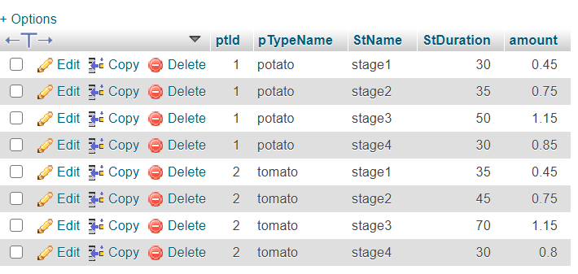

## Figure 1-View detail for each plant in plant's tablse

# steps adding and viewing fields

### adding field

from desktop application insert field name, with, height and date then add field to database.

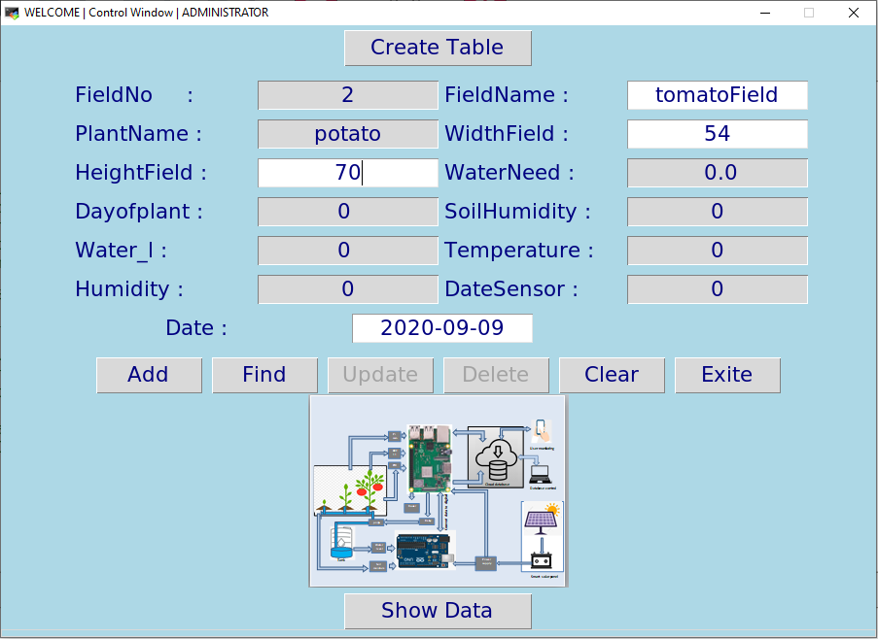

* + 1. field in database after adding

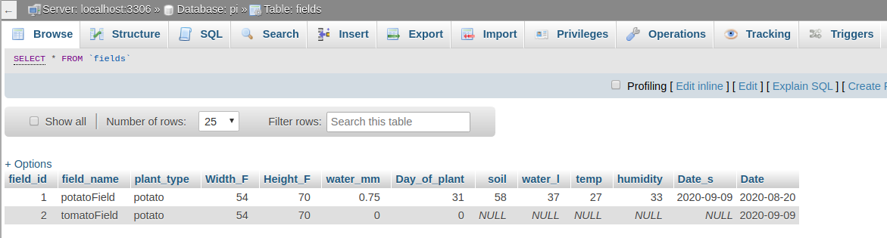

* + 1. Appling AI algorithm.

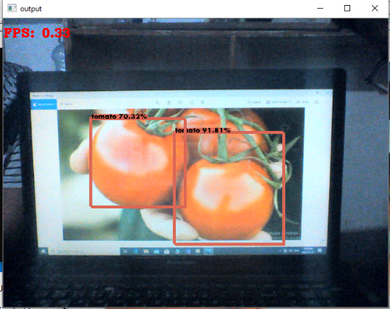

* + 1. Field after applying AI algorithm

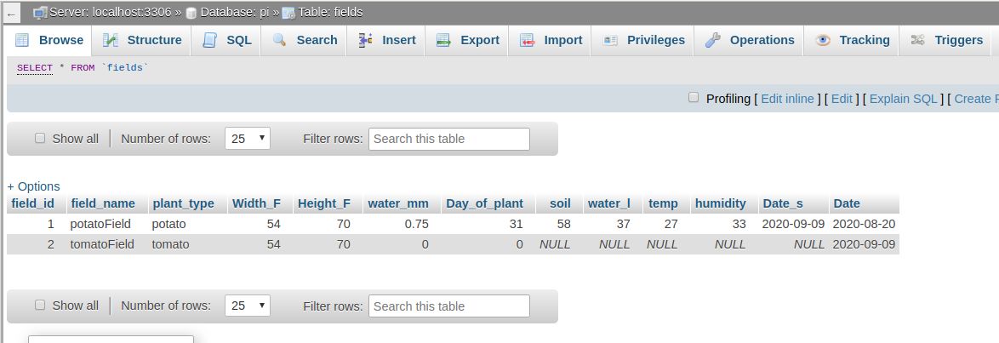

* + 1. showing the filed

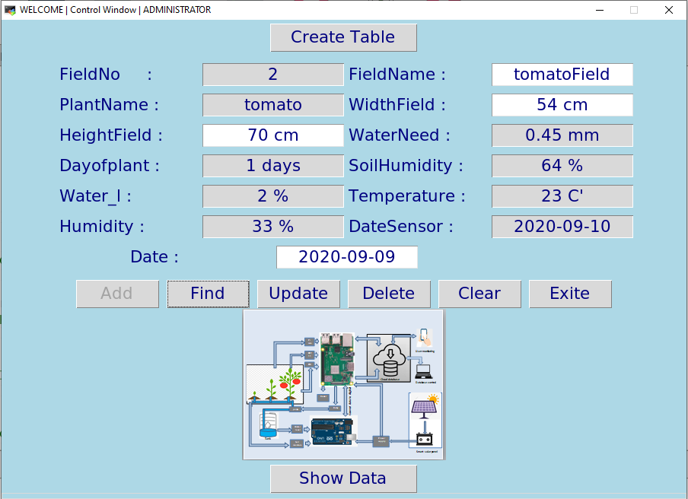

* + 1. show details of first stag



* + 1. show details of second stat

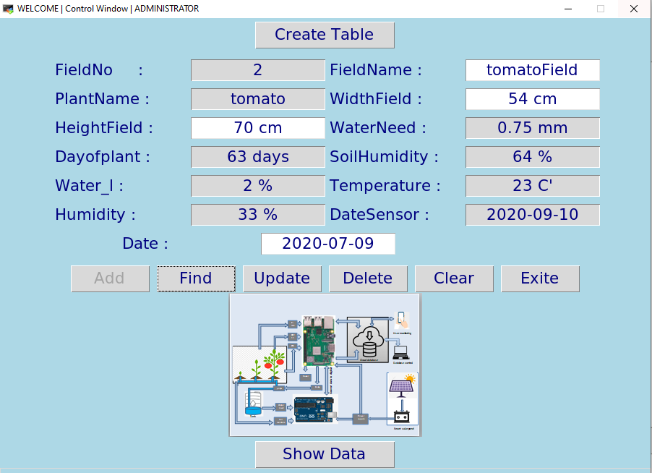

1.1.8 show details of third stat

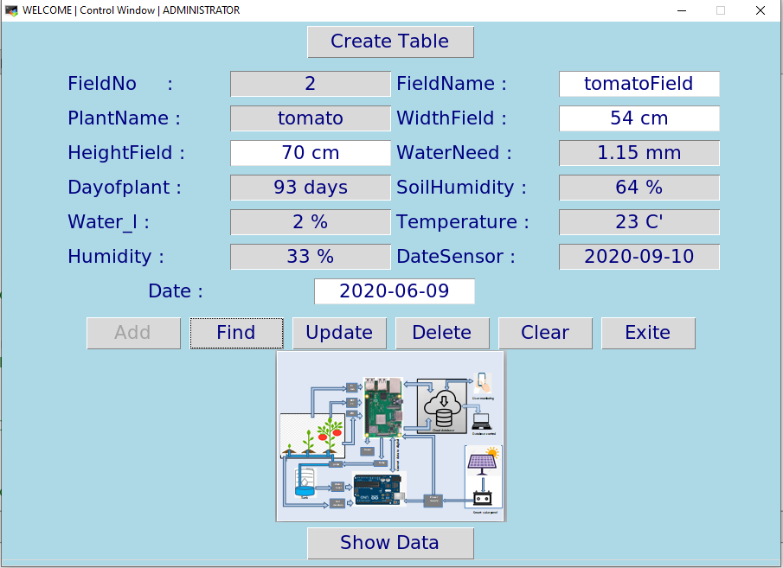

* + 1. show details of forth stat

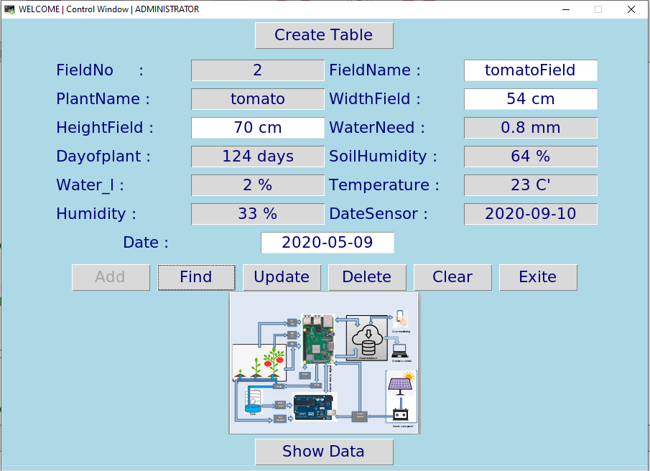

1.1.10 show End the season

